Student’s name | …………………………………………………….…… | Grade | 2
Subject | Computer | Week No. | 10
Lesson Title |  | Unit
Revision Worksheet

Question A: Match the following

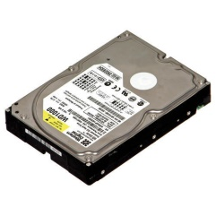 | UPS
 | HEADPHONE
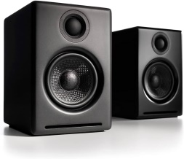 | HARD DISK
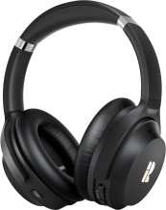 | PROCESSOR
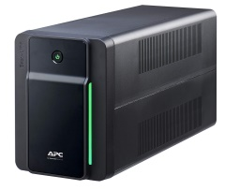 | SPEAKER

Question B: Match the following

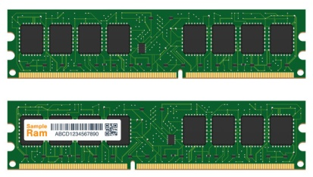 | WEBCAM
 | PRINTER
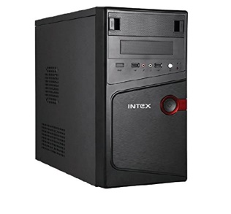 | RAM
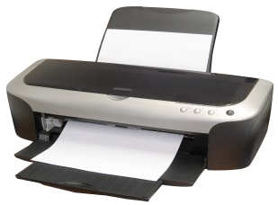 | DISC
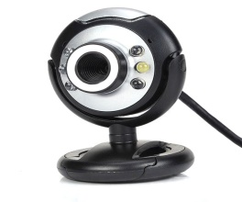 | CPU

Question C: Fill in the blank with the correct file types.

File | File Type | File | File Type
 | _______________ |  | _______________
 | _______________ |  | _______________

Question D: Fill in the blanks.
- The memory device that is used to store information in a computer is called as a _____
- All the software are saved in the ___________ drive.
Question E: State whether the statements are True/False.
- Files of same name cannot exist in same folder,
_____________
- Hard disk is not a memory device.
_____________

Question F: Fill in the blank with the words in the box below.

Image Name Extension Music Movies and TV

1. In flower.jpg, ‘.jpg’ is an _____________

2. We can identify the type of file by its ______________ and _________

3. .png is a type of _________ file.

4. .mp4 is a type of _________ file.

5. __________ is used to watch a video on a computer.

Question G: State whether the below statements are True or False.

1. We have two button on a mouse, left and right.
(a) True (b) False
2. The wheel on the mouse is called Scroll wheel.
(a) True (b) False
3. We use cut and paste to move a files.
(a) True (b) False
4. We use paste command to create a duplicate files.
(a) True (b) False
5. We use right click to open the home menu.
(a) True (b) False

Question H: Fill in the blank with the words in the box below.

Cut and Paste Copy and Paste Right Paste Copy

1. We use _____________ and ___________ command to move files.

2. We use______________ and _________ command to create duplicate files.

3. We use _________ click to open the option menu.

4. We cannot use the _________ command without copy or cut.

5.We can use the __________ command to duplicate text, files and folders.

ANSWER KEY
Question A: Match the following

 | UPS
 | HEADPHONE
 | HARD DISK
 | PROCESSOR
 | SPEAKER

Question B: Match the following

 | WEBCAM
 | PRINTER
 | RAM
 | DISC
 | CPU

Question C: Fill in the blank with the correct file types.

File | File Type | File | File Type
 | Picture |  | Document
 | Video |  | Audio

Question D: Fill in the blanks.
- The memory device that is used to store information in a computer is called as a ROM
- All the software are saved in the Hard drive.
Question E: State whether the statements are True/False.
- Files of same name cannot exist in same folder,
True
- Hard disk is not a memory device.
False

Question F: Fill in the blank with the words in the box below.

Image Name Extension Music Movies and TV

1. In flower.jpg, ‘.jpg’ is an Image

2. We can identify the type of file by its Name and Extension

3. .png is a type of Image file.

4. .mp4 is a type of Music file.

5. Movies and TV is used to watch a video on a computer.

Question G: State whether the below statements are True or False.

1. We have two button on a mouse, left and right.
(a) True (b) False
2. The wheel on the mouse is called Scroll wheel.
(a) True (b) False
3. We use cut and paste to move a files.
(a) True (b) False
4. We use paste command to create a duplicate files.
(a) True (b) False
5. We use right click to open the home menu.
(a) True (b) False

Instruction: Fill in the blank with the words in the box below.

Cut and Paste Copy and Paste Right Paste Copy

1. We use Cut and Paste command to move files.

2. We use Copy and Paste command to create duplicate files.

3. We use Right click to open the option menu.

4. We cannot use the Paste command without copy or cut.

5.We can use the Copy command to duplicate text, files and folders.

